GCM THEATRE PROUDLY PRESENTS:
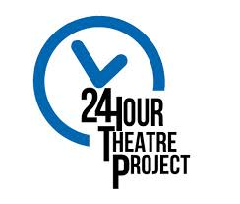

Thursday, 4/5/18: Playwriting and Directing Applications Due

(Applications are Located on the Call Board)

Friday, 4/6/18:
5:00pm- Playwrights are contacted
6:00pm- 1 Hour Playwrighting Workshop with Mrs. Saunders
7:00pm- BEGIN writing

Saturday, 4/7/18:
6:00am- Directors are contacted
7:00am- STOP writing- 1 Hour Meeting with Directors & Playwrights.
8:00am- 1 Hour Directing Workshop with Mrs. Saunders
9:00am- AUDITIONS (Open to Junior High Students as well)
10:00am- Show are cast- REHEARSALS BEGIN
6:00pm- Break for dinner (Bring $5 for Dinner)
​7:00pm- PERFORMANCE

